**PRE PLE -2020**

**P.7 INTEGRATED SCIENCE SET I**

*Time allowed: 2 Hours 15 minutes*

Candidates’ Names: ...................................................................................

Index No.

School: ...................................................................................................................

***SECTION A***

1. What happens to vapour when condensed?

________________________________________________

2. Give any one importance of living organism as a component of soil.

____________________________________________

3. Why is a spider regarded as an arachnid?

________________________________________________

4. How do premolars help in the digestion of food?

________________________________________________

5. What type of change does a snake undergo when it sheds off the old skin and develops a new one?

________________________________________________

6. What does the term skeleton mean?

_____________________________________________________________________________________________

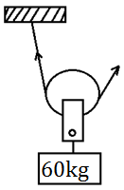 ***The diagram below is of a pulley. Study it and answer the questions 7 and 8***.

7. What type of pulley is shown in the diagram above?

________________________________________________

8. Calculate the effort needed to raise to the load shown in the diagram above.

9. Why should children be given food rich in proteins?

________________________________________________________________________________________________

10. How is the fertilization of eggs of an amphibian different from those of reptiles?

________________________________________________________________________________________________

11. Name the method that is used to find the volume of an Irish potato.

________________________________________________

12. Magnets can’t separate nails from iron fillings. Why is it easy to separate sugar from iron fillings?

________________________________________________________________________________________________

13. State any one physical characteristic that occurs in only female adolescents.

________________________________________________

14. Give one reason why people should test their blood for HIV and AIDS?

________________________________________________

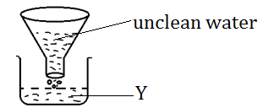***The diagram below is of a method of making water clean. Use it to answer questions***.

15. Why is the filtrate marked Y not advisable for drinking?

_____________________________________________________________________________________________

16. Convert 680F to Celsius scale.

17. How are testes and anthers similar in their function?

_____________________________________________________________________________________________

18. Which part of the human eye can be compared to the film of a camera?

_____________________________________________________________________________________________

19. Identify any one example of land pollutant.

_____________________________________________________________________________________________

20. Why are worker bees referred to as sterile bees in a bee hive?

_____________________________________________________________________________________________

21. Which type of digestion takes place in the stomach?

_____________________________________________________________________________________________

***The diagram below is of a thermos flask***.

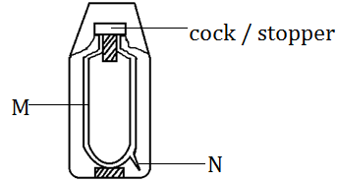

22. State the function of the part marked N.

________________________________________________________________________________________________

23. Give any one example of fossil fuel.

_____________________________________________________________________________________________

24. Write down one principle of reflection of light.

_____________________________________________________________________________________________

25. Identify the main function of fungi in a food chain.

_____________________________________________________________________________________________

26. Give any one way rusting affects metals.

_____________________________________________________________________________________________

27. Kapere walks bare footed from his home to school. Identify any one problem Kapare is most likely to face after sometime.

_____________________________________________________________________________________________

28. In the space below, draw a stamen and show the filament

29. Give any one reason why friction is a useless force in nature.

________________________________________________________________________________________________

30. Identify any one way why sweating is important to a human body.

_____________________________________________________________________________________________

31. Electricity is a poor master but a good servant to the environment. Using the statement, state one reason for its being a good servant to the environment.

_____________________________________________________________________________________________

32. Identify one way of controlling diseases among school going children without using drugs.

_____________________________________________________________________________________________

33. Write down any one way a farmer can improve on his local breed of pigs on his piggery. ________________________________________________

________________________________________________

34. Apart from carbondioxide, state any one other material plants use for photosynthesis in the environment.

_____________________________________________________________________________________________

35. How is black jack adopted to its mode of dispersal?

_____________________________________________________________________________________________

36. Name the state of matter marked X below.

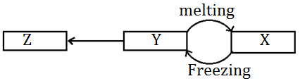

_____________________________________________________________________________________________

37. How is the propagation of cassava different from that of carrots?

________________________________________________________________________________________________

38. Name any one immunisable air borne disease that affects the lungs.

_____________________________________________________________________________________________

39. Which instrument measures the speed of wind?

_____________________________________________________________________________________________

40. Suggest any one way of conserving soil as a resource.

_____________________________________________________________________________________________

***SECTION B: 15 Questions (60 Marks)***

41. (a) Give the difference between drowning and near drowning.

________________________________________________________________________________________________________________________________________________

(b) State any two causes of near drowning in a home.

(i) ______________________________________________

(ii) ______________________________________________

(c) What first Aid will a Seven year old boy give to friend who has near drowned?

________________________________________________________________________________________________

42. (a) Burning is considered to be a chemical change. Give any other two examples of chemical changes.

(i) __________________________________________________________________________________________

(ii) _________________________________________________________________________________________

(b) Write down any one reason why burning is considered to be a chemical change. ________________________________________________

________________________________________________

(c) Name any one natural change that degrades the environment.

_____________________________________________________________________________________________

43. ***The diagram below shows types of lenses***.

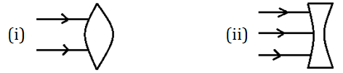

(a) Complete the diagrams above to show the light rays after passing through the lenses.

(b) Identify the eye defects corrected by lenses marked.

(i) __________________________________________________________________________________________

(ii) _________________________________________________________________________________________

44. (a) How is photosynthesis different from transpiration?

________________________________________________________________________________________________________________________________________________

(b) Identify any one by-product of photosynthesis.

_____________________________________________________________________________________________

(c) Which component of air is decreased in the atmosphere during the process of photosynthesis?

_____________________________________________________________________________________________

(d) Write down any one factor that affects the rate of transpiration.

_____________________________________________________________________________________________

45. (a) Walukagga is a musician, how is he able to produce sound?

________________________________________________________________________________________________

(b) Identify any two devices Walukagga use to store sound.

(i) __________________________________________________________________________________________

(ii) ____________________________________________

(c) Give any one factor that determines the pitch of sound.

_____________________________________________________________________________________________

46. ***The diagram below shows a fish. Use it to answer questions that follow***.

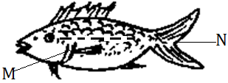

(a) Name the part marked N.

_____________________________________________________________________________________________

(b) State the function of part M on the fish.

_____________________________________________________________________________________________

(c) Give one way in which a fish is adopted to live in water.

_____________________________________________________________________________________________

(d) Why are people advised to feed their children suffering from Kwashiorkor on fish? ________________________________________________

________________________________________________

47. Mutyaba weighs 80kg sitting 3m away from the pivot and Bwanika who weighs 40kgs sits on the opposite side of the see saw in order to balance with Mutyaba.

(a) How far is Bwanika from Mutyaba?

(b) State the principle of moments.

________________________________________________________________________________________________

48. (a) How does food move through the alimentary canal of humans?

________________________________________________________________________________________________

(b) Name the condition in which enzymes like salivary amylase work best.

_____________________________________________________________________________________________

(c) Identify any one disease that affects the digestive system.

_____________________________________________________________________________________________

(d) Suggest any one health habit that maintains the proper functioning of the digestive system.

_____________________________________________________________________________________________

49. ***The diagram below is of an electric bell. Use it to answer questions that follow***.

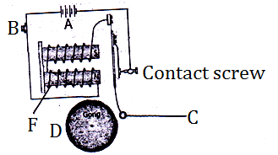

(a) Name the parts marked.

(i) A __________________________________________

(ii) B __________________________________________

(b) In which way is C useful on an electric bell?

________________________________________________

________________________________________________

(c) Apart from an electric bell, write down any one other device which uses Magnetism and electricity to operate.

_____________________________________________________________________________________________

50. Match the organism in A to the diseases they cause in B.

List A List B

Chlamydia Typhoid

Plasmodia River blindness

Salmonella typhi Malaria

Onchocerca Vulvulus Trachoma

(i) Chlamydia ________________________________________________

(ii) Salmonella typhi ________________________________________________

(iii) Onchocerca Vulvulus __________________________________________________

(iv) Plasmodia ____________________________________________

51. (a) What is incubation as used in poultry?

________________________________________________

________________________________________________

(b) Give any one disadvantage of using natural incubation.

________________________________________________

________________________________________________

(c) Mention any two factors that may make an egg fail to hatch.

(i) _____________________________________________

(ii) _____________________________________________

52. (a) Explain the following terms:

(i) Energy resources

________________________________________________

(ii) A resource

________________________________________________

________________________________________________

(b) Apart from hydro electricity, write down any one other energy resource obtained from water.

________________________________________________________________________________________________

(c) In which way are animals used as an energy resource?

________________________________________________________________________________________________

53. (a) What are health parades?

________________________________________________

_______________________________________________

(b) Give any one reason why health parades are conducted in your school.

________________________________________________

________________________________________________

(c) Apart from teachers on duty, write down one group of people who conduct health parades in your school.

_____________________________________________________________________________________________

(d) Suggest any one way of maintaining the compound of your school clean.

________________________________________________________________________________________________

54. ***The diagram below shows the human respiratory system. Use it to answer questions that follow***.

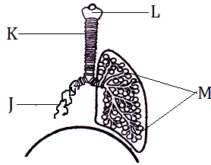

(a) Name the parts labeled.

(i) M ________________________________________________

(ii) J ________________________________________________

(b) How is part marked K adapted to its function?

________________________________________________________________________________________________

(c) Identify any one non infectious disease that attacks the above system.

_____________________________________________________________________________________________

55. (a) Differentiate between root tubers and stem tubers.

_______________________________________________________________________________________________________________________________________________

(b) How are the following crops harvested?

(i) Cassava ________________________________________________

(ii) Carrot ________________________________________________

(c) Identify any one pest that attacks root tubers in the garden.

_____________________________________________________________________________________________

***END***